**LAB-1**

**(a) Creating a registration Page with HTML 5 Validation**

**Code Snippet:**

<!DOCTYPE html>

<html lang="en">

<head>

<meta charset="UTF-8">

<meta name="viewport" content="width=device-width, initial-scale=1.0">

<title>Document</title>

</head>

<body bgcolor="#333" text="white">

<form action="#">

<table align="center" cellpadding="8" border="1" >

<tr >

<td>First Name:</td>

<td><input type="text" ></td>

<td>Last Name:</td>

<td><input type="text" ></td>

</tr>

<tr>

<td>Email</td>

<td colspan="3"><input style="width: 98%;" type="email" name="email" id=""></td>

</tr>

<tr>

<td>Phone</td>

<td colspan="3"><input style="width: 98%;" type="tel" name="email" id=""></td>

</tr>

<tr>

<tr>

<td>City</td>

<td colspan="3"><input style="width: 98%;" type="text" name="email" id=""></td>

</tr>

<tr>

<td>Age</td>

<td colspan="3"><input style="width: 98%;" type="text" name="email" id=""></td>

</tr>

<tr>

<td>Profession</td>

<td colspan="3"><input style="width: 98%;" type="text" name="email" id=""></td>

</tr>

<td>Password</td>

<td colspan="3"><input style="width: 98%;" type="password" name="email" id=""></td>

</tr>

<tr>

<td>Confirm Password</td>

<td colspan="3"><input style="width: 98%;" type="password" name="email" id=""></td>

</tr>

<tr><td>Gender</td>

<td > <input type="radio" name="gender" id=""> Male</td>

<td colspan="2"> <input type="radio" name="gender" id="">Female </td>

</tr>

<tr>

<td align="center" colspan="4"><input type="submit" value="Submit"></td>

</tr>

</table>

</form>

</body>

</html>

**Final Outcome:**

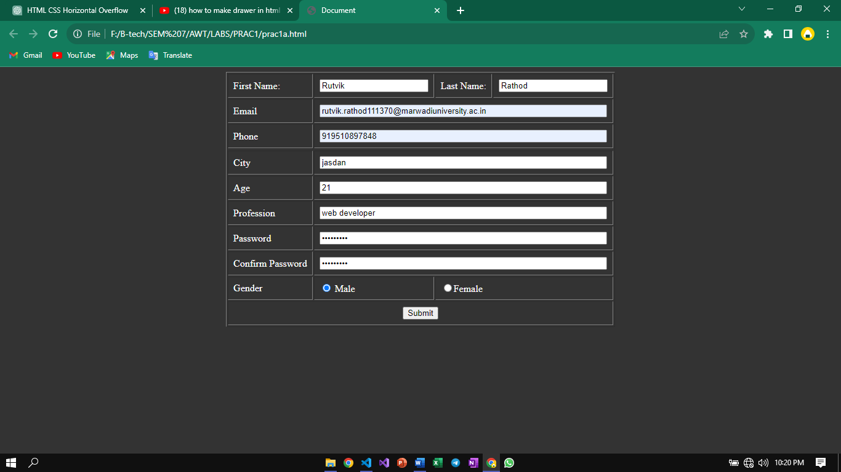

**(b) Adding a external stylesheet to make registration form look elegant**

**Code Snippet**

<!DOCTYPE html>

<html lang="en">

<head>

<meta charset="UTF-8">

<meta name="viewport" content="width=device-width, initial-scale=1.0">

<title>Practical1B</title>

<link rel="stylesheet" href="prac1b.css">

<link rel="stylesheet" href="https://cdnjs.cloudflare.com/ajax/libs/font-awesome/6.4.0/css/all.min.css">

</head>

<body>

<div class="container">

<div class="heading">

Welcome....

</div>

<form action="#" method="get">

<div class="ip-box-container">

<div class="ip-box">

<i class="fa-solid fa-user"></i>

<input type="text" placeholder="Username">

</div>

<div class="ip-box">

<i class="fa-solid fa-envelope"></i>

<input type="email" placeholder="Email">

</div>

<div class="ip-box">

<i class="fa-solid fa-phone"></i>

<input type="tel" placeholder="Phone">

</div>

<div class="ip-box">

<i class="fa-solid fa-lock"></i>

<input type="password" placeholder="Password">

</div>

<div class="ip-box">

<i class="fa-solid fa-lock"></i>

<input type="password" placeholder="Confirm Password">

</div>

<div class="submit-box">

<input type="reset">

<input type="submit" >

<a href="#">Log in instead</a>

</div>

</div>

</form>

</div>

</body>

</html>

**CSS:**

@import url('https://fonts.googleapis.com/css2?family=Kanit:wght@300;400&family=Poppins:wght@300&family=Roboto:ital@0;1&family=Ubuntu:wght@300;400&display=swap');

*{

margin:0;

padding: 0;

box-sizing: border-box;

font-family: 'Roboto', sans-serif;

}

body{

background-color: #222;

height: 100vh;

width: 100vw;

display: flex;

justify-content: center;

align-items: center;

}

.container .heading{

font-size: 2rem;

position: absolute;

top:20px;

left: 50%;

transform: translateX(-50%);

color: #Fff;

font-weight: 500;

}

.container {

background: linear-gradient(to right,rgb(229, 255, 0),rgb(0, 128, 85));

height: 460px;

width: 35%;

border-radius: 10px;

position: relative;

display: flex;

justify-content: center;

align-items: center;

}

.container form{

height: 90%;

display: flex;

justify-content: center;

align-items: center;

width: 100%;

}

.container .ip-box-container{

display: flex;

flex-direction: column;

gap:1.1rem;

width:80%;

}

.container .ip-box{

width: 100%;

display: flex;

background-color: #fff;

padding: 0 10px;

align-items: center;

}

.container .ip-box i{

color: rgb(26, 136, 170);

}

.container .ip-box input{

background: none;

border: none;

outline: none;

}

.container .ip-box-container .ip-box input{

padding: 10px;

width: 100%;

}

.submit-box{

display: flex;

justify-content: space-between;

margin-top: 10px;

align-items: center;

}

.submit-box a{

color: #fff;

}

.submit-box input{

padding: 10px;

width: 7rem;

border-radius: 10px;

border: none;

background-color: rgb(24, 83, 172);

color: #fff;

font-size: 0.91rem;

letter-spacing: 0.04rem;

transition: 0.5s ease;

}

.submit-box input:hover{

transform: scale(1.04);

background-color: rgb(78, 125, 196);

cursor: pointer;

}

**Final Outcome:**

